Name: _______________________
Analyzing Propaganda
Directions: During the 1950s, when United Fruit Company and the U.S. government engineered the coup d’etat which drove Jacobo Arbenz from power, advertisements encouraged people in the U.S. to fight communism in many areas of their lives. Please look at the following poster and take notes at your observations and the purpose.
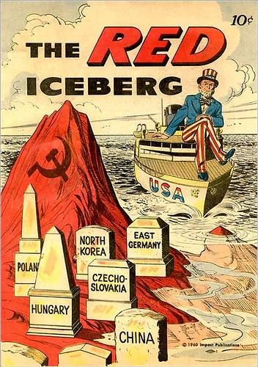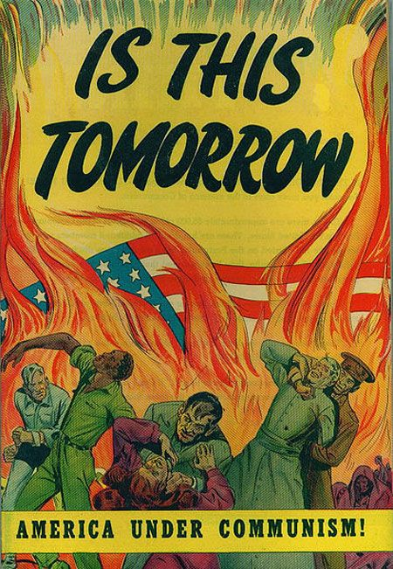

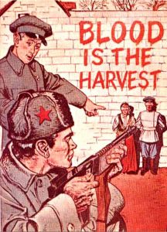 \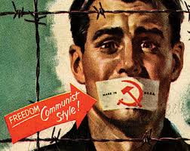

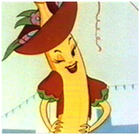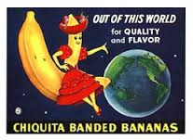
- By the 1930’s United Fruit had consolidated its power as the world’s major banana producing and marketing company.
- From the 1920’s, United Fruit controlled more than 70% of the banana business!
- Ubico (one of the most infamous dictators) supported this company. He used force and intimidation, and racism to control the population. He was a strong ally to the U.S. and welcomed foreign investors.
- Eventually, Ubico is overthrown by Arbenz, but United Fruit is already an established and powerful entity in Guatemala.
- Arbenz was a “champion of the people” who tried to break up monopolies . He created an income tax to do so.
Why do you think the US engineered the coup d’etat?

