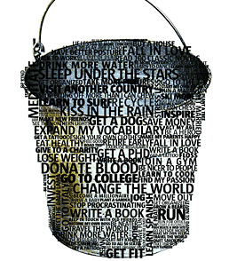
Bucket List Assignment
Here are some questions to think about when creating your Bucket List.
- What are some academic goals that you would like to achieve?
- What if you were to die tomorrow? What would you wish you could do before you die?
- What have you always wanted to do but have not done yet?
- What will you do if you have unlimited time, money and resources?
- Any countries, places or locations you want to visit?
- What are your biggest goals and dreams?
- What do you want to see in person?
- What achievements do you want to have?
- What experiences do you want to have / feel?
- Are there any special moments you want to witness?
- What activities or skills do you want to learn or try out?
- What are the most important things you can ever do?
- What would you like to say/do together with other people? People you love? Family? Friends?
- Are there any specific people you want to meet in person?
- What do you want to achieve in the different areas: Social, Love, Family, Career, Finance, Health (Your weight, Fitness level), Spiritual?
- What do you need to do to lead a life of the greatest meaning?
Need Ideas - Do Some Research
Visit the following websites that provide ideas about creating a bucket list:
http://abundance-blog.marelisa-online.com/2010/05/21/bucket-list-ideas/
http://thingstodo.oncelife.com.au/

Assignment: You are going to create a bucket list with 25 items. Each item will be written in a complete sentence, and no two consecutive sentences can start the same way. Vary the length and type of sentences. Use a 12 font and double space. Print your assignment. Turn it in on: _____________

