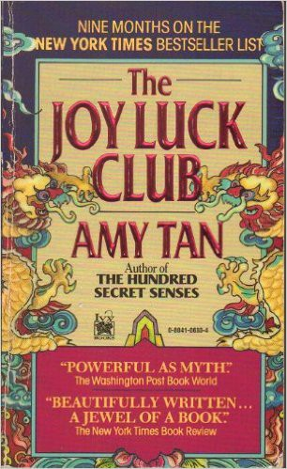

Name: Date: Period:

**Close Reading Organizer - Part 1, Chapter 2: Scar**

**Directions:** Read each summary entry and think about which themes listed in the Themes Key apply to it, then color

in those themes in the Theme Tracker. Next, write a few sentences of Analysis to explain how the themes you chose apply to each summary section.

**Themes Key**

Mother-Daughter Relationships

Storytelling and Tradition

Immigration, Language, and Mistranslation Fate and Autonomy

Sacrifice

Sexism and Power

**Summary**

**Theme Tracker**

**Your Analysis**

In “Scar,” **An-mei** recalls her childhood in China, when she lived with her grandmother rather than her mother. **Popo**, Chinese for ‘grandma,’ would regularly frighten her by saying **An-mei’s mother** was a ghost; in those days, a ghost meant anything they “were forbidden to talk about,” not that her mother was dead. Over time, An-mei forgets about her mother entirely.

1

2

3

4

5

6

**Popo** becomes ill and bedridden in 1923, when **An-mei** is nine years old. Popo continues to scare her by telling bedside stories about disobedient girls who receive horrible bodily punishments. Right before she loses the ability to speak, she warns An- mei to never say her mother’s name out loud, or she’d be spitting on An-mei’s deceased father’s grave.

1

2

3

4

5

6

Later that summer, An-mei’s aunt loses her temper and reveals to **An-mei** that **An-mei’s mother** had run off with a man named **Wu Tsing** to be his lowly fourth wife, when An-

1

2

3

4

5

6

6

5

4

3

2

1

**Summary**

**Theme Tracker**

**Your Analysis**

mei was four. Her re-marriage was so shameful that the family exiled her, calling her a traitor to their ancestors. An-mei realizes **Popo**’s stories were meant as warnings against her mother’s bad behavior, and disappointedly imagines her mother as a flighty woman with no care for honor or familial responsibility.

Soon after that revelation, a pretty woman arrives at **Popo**’s house to nurse Popo back to health, and **An-mei** immediately knows it’s her mother even though she has no memory of her mother’s face. While other relatives ridicule her or ignore her like a ghost, **An-mei** watches her mother urge Popo out of her near-death slumber, telling her “your daughter is back.”

1

2

3

4

5

6

Later that afternoon, **An-mei’s mother** calls **An-mei** over to brush her hair, scolding her shyness by saying “An-mei, you know who I am.” While brushing, An-mei’s mother touches an old scar under An-mei’s chin.

The touch revives the memory of the night her mother left five years ago.

1

2

3

4

5

6

**An-mei’s mother** had begged **An-mei** to leave with her that night, but **Popo** refused to let her go, arguing that An-mei’s mother was a disgrace, and that the shame would infect An-mei’s life too. Four-year-old An- mei reached out for her mother and accidentally tipped a boiling hot pot of soup onto herself, burning her so badly that Popo thought she’d die that night. The family threw An-mei’s mother out, and Popo took care of An-mei as the burn became a scar.

1

2

3

4

5

6

Right before **Popo** dies**, An-mei** discovers her mother cutting off a piece of her arm and cooking it in a soup made with “magic in the ancient tradition”—a soup which is supposed to heal anything. **An-mei’s mother** then attempts in vain to feed the

1

2

3

4

5

6

**Summary**

**Theme Tracker**

**Your Analysis**

broth to Popo, desperate to cure her. From this act, An-mei recognizes and admires “the pain of the flesh and the worth of the pain,” and the lengths that a daughter would go to honor her mother.