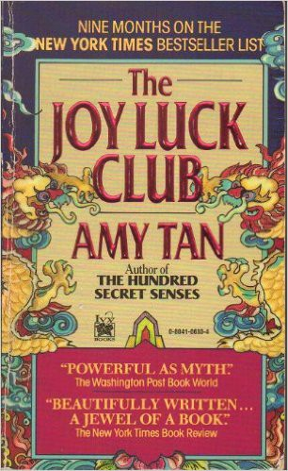

Name: Date: Period:

**Close Reading Organizer - Part 1, Chapter 4: The Moon Lady**

**Directions:** Read each summary entry and think about which themes listed in the Themes Key apply to it, then color

in those themes in the Theme Tracker. Next, write a few sentences of Analysis to explain how the themes you chose apply to each summary section.

**Themes Key**

Mother-Daughter Relationships

Storytelling and Tradition

Immigration, Language, and Mistranslation Fate and Autonomy

Sacrifice

Sexism and Power

**Summary**

**Theme Tracker**

**Your Analysis**

**Ying-ying** regrets that she kept her true nature hidden while raising her daughter, **Lena**, and instead acted so meek and quiet that Lena stopped noticing her. For many years, Ying-ying forgot the source of her silence, but suddenly remembers the central event when watching Lena go through a divorce: the Moon festival when Ying-ying was four.

1

2

3

4

5

6

On that festival day in China many years ago, **Ying-ying** remembers how hot it was. Despite the heat, her nanny **Amah** dresses her in heavy formal clothes and tiger- patterned slippers that make Ying-ying whine. Amah tells her about the Moon Lady, who grants secret wishes during the festival but shuns selfish desires. If Ying-ying is good, she’ll get the chance to meet the Moon Lady and have a wish granted. When Ying-ying loudly wishes to be out of her robes, Amah calls that a selfish desire because Ying-ying voiced it out loud.

1

2

3

4

5

6

6

5

4

3

2

1

**Summary**

**Theme Tracker**

**Your Analysis**

**Ying-ying**’s extended family boards a lavish boat on a nearby lake to celebrate the Moon festival, and Ying-ying sneaks away to watch fishermen catch seafood and the boat’s chef slaughter animals for the evening’s banquet. Before she knows it, Ying-ying is covered in eel blood and fish scales from sitting in the kitchen. Thinking she can avoid punishment by dyeing her fancy clothes entirely red, she covers herself in blood. **Amah**, in a panic, discovers Ying- ying soaked in blood and scolds her for misbehaving. While the rest of the family celebrates in the front of the boat, Ying-ying is left to sit alone in the back, in only her undergarments and tiger slippers.

1

2

3

4

5

6

Hours pass, and **Ying-ying** hopes **Amah** will come retrieve her as night falls. Instead, fireworks launch off the other boats on the lake, scaring Ying-ying and causing her to fall off the back of the boat. She flails in the lake water, unable to find the surface, and tries to call out Amah’s name. Eventually, she gets caught in a fishing net, and an old couple pull her out of the water. They try to locate Ying-ying’s boat on the crowded lake, but she can’t tell which one is her family’s. The old couple end up placing her on shore, assuring her that her family will find her once they notice she’s missing.

1

2

3

4

5

6

Rather than wait on shore, **Ying-ying** follows the sound of music to a stage, where a play retelling the Moon Lady myth is happening. Though too far from the stage to see details, Ying-ying is mesmerized by the Moon Lady’s beauty and the sorrow of her banishment for defying her husband, the Sun. Ying-ying relates the Moon Lady’s loss to her own loss at getting separated from her family.

1

2

3

4

5

6

After the performance, **Ying-ying** eagerly seeks out the Moon Lady backstage,

1

2

3

4

5

6

**Summary**

**Theme Tracker**

**Your Analysis**

thinking the goddess will answer her wish and reunite her with her family. To her horror, Ying-ying discovers that the Moon Lady is a male actor in drag, shattering her naïve hopes.

**Ying-ying** as an adult has pushed this memory away until she sees **Lena** suffering in a loveless marriage. At that moment, Ying-ying remembers the wish she wanted to tell the Moon Lady: she wished to be found.

1

2

3

4

5

6