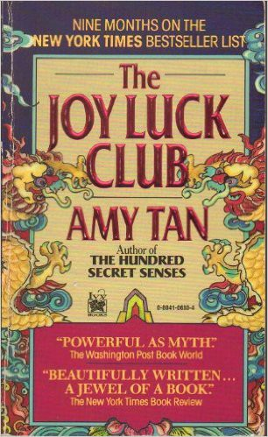

Name: Date: Period:

**Close Reading Organizer - Part 3, Chapter 4: Best Quality**

**Directions:** Read each summary entry and think about which themes listed in the Themes Key apply to it, then color

in those themes in the Theme Tracker. Next, write a few sentences of Analysis to explain how the themes you chose apply to each summary section.

**Themes Key**

Mother-Daughter Relationships

Storytelling and Tradition

Immigration, Language, and Mistranslation Fate and Autonomy

Sacrifice

Sexism and Power

**Summary**

**Theme Tracker**

**Your Analysis**

On the Lunar New Year holiday before she passes away, **Suyuan** gives **June** “her life’s importance,” a jade pendant on a gold chain. June is unsure why Suyuan calls it that, and Suyuan dies before June thinks to ask her. June reflects on her inability to make sense of her grief without her mother’s help to get her through.

1

2

3

4

5

6

**June** then flashes back to that Lunar New Year day, when she went with **Suyuan** to Chinatown to buy ten whole crabs for a holiday dinner with the Jongs. Eating a large, healthy crab at New Year’s signals good fortune for the rest of the year, and Suyuan sifts through a large tank to find the best live crabs. June accidentally pulls out a crab with a missing leg, a bad omen, but the storekeeper makes her buy it. Suyuan tells June that it counts as an extra eleventh crab, which shouldn’t affect their luck.

1

2

3

4

5

6

At **Suyuan**’s dinner party, **Waverly** ruins Suyuan’s head count by bringing her daughter **Shoshana** and giving her the

1

2

3

4

5

6

6

5

4

3

2

1

**Summary**

**Theme Tracker**

**Your Analysis**

biggest, best crab to eat. She also takes the second-best and third-best for her fiancé, **Rich**, and herself. By the time the plate of crabs reaches Suyuan and June, only a smaller crab and the broken-limbed crab remain. Without hesitation, June reaches for the broken crab so her mother can have the luckier whole one, but Suyuan makes her take the better one and throws the broken one away. While everyone else enjoys their dinners, Suyuan goes hungry.

Midway through dinner, conversation strikes back up again. **Waverly** compliments **June**’s new haircut, but then acts horrified when she learns that June goes to a gay hairstylist, who “could have AIDS.” Waverly recommends her own stylist, but quickly notes that he’s probably too expensive for June’s small budget.

1

2

3

4

5

6

Angry at **Waverly**’s pettiness, **June** retorts that she’d have more money if Waverly’s advertising firm paid her for completed work. Waverly coolly dismisses her, saying June’s writing was too unsophisticated and the firm couldn’t use any of it. She mocks June’s language, considering it old- fashioned in style. **Suyuan** agrees that her daughter is less sophisticated than Waverly. Humiliated, June carries dirty plates into the kitchen so no one sees her tears.

1

2

3

4

5

6

After everyone leaves, **June** asks **Suyuan** what was wrong with the broken crab, and Suyuan says that it had died before being cooked, leaving it with a bad taste. June asks what Suyuan would’ve done if someone else had chosen it, but Suyuan proudly says that only June, who thinks differently than most, would sacrifice the best quality meal for someone else’s sake. Suyuan then gives June her jade pendant, which she’s been waiting to pass on for many years.

1

2

3

4

5

6