College Brochure Assignment

You will be assigned a college or university to research, and you will report your findings to the class. You will research your school on the Internet to find detailed, relevant information about the school. Once you have researched the school, you will create a brochure with which to advertise your college. You will use Noodle Tools to properly cite all of your information and to create a Works Consulted, which must be included on the back of your brochure. Finally, you will share some key information with the class on the due date: name of school and type, location, and two interesting facts.

On your brochure and in your speech, many of these items should be covered:

- The type of school
- The location of the school (rural, city, suburb, as well as the specific place)
- The year it was founded
- The school’s specialty
- The size of the school (physical and population)
- Tuition
- Average admission GPA
- Number of applicants
- Situation of on and off-campus housing
- Number of faculty members (ratio of teachers to students)
- Best and most popular majors
- Mascot
- Places of interest located near the school
- Famous people that have attended there
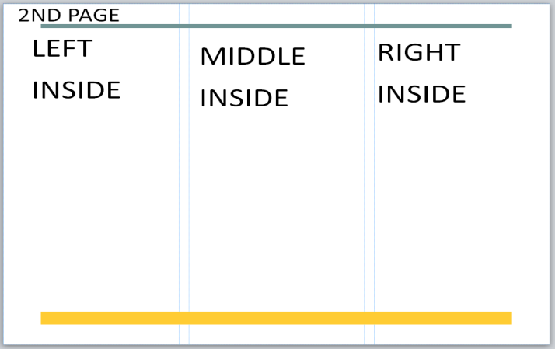

You may also cover other interesting information that you discover in your research. Try using Internet sites such as Princeton Review, U.S. News and World Reports, and Newsweek for information. You will also find valuable information on the school’s own website.

Remember to create citations in NoodleTools for the information you find AS you research, not after! You must have at least two different sources listed on your Works Consulted. DUE DATE: ________

