Shakespeare
The Globe Theatre Writing Assignment
Directions: Read, review, and annotate the following four sources that all contain very important information regarding the structure and popularity of the Globe Theatre during the 1500s and 1600s. Your assignment is to write two body paragraphs document in which you explain TWO of the following:
- Beginnings of the theatre
- Layout of the theatre
- The theatre’s audience
- The closing of the theatre
*You must use two quotes in each body paragraph. Cite them as follows: (Source A, B, C, or D).
*Make sure that you introduce each source (attach them to your words) to the best of your ability (depending on the amount of information you have been given).
Source A: The original Globe was an Elizabethan theatre which opened in Autumn 1599 in Southwark, on the south bank of the Thames, in an area now known as Bankside. It was one of several major theatres that were located in the area, the others being the Swan, the Rose and The Hope. The Globe was the principal playhouse of the Lord Chamberlain's Men (who would become the King's Men in 1603). Most of Shakespeare's post-1599 plays were staged at the Globe, including Julius Caesar, Macbeth, Othello, King Lear and Hamlet.
The Globe was built in 1599 using timber from an earlier theatre, The Theatre, that had been built by Richard Burbage's father, James Burbage, in Shoreditch in 1576. The Burbages originally had a 20-year lease of the site on which the Theatre was built. When the lease ran out, they dismantled The Theatre beam by beam and transported it over the Thames to reconstruct it as The Globe.
Like all the other theatres in London, the Globe was closed down by the Puritans in 1642. It was destroyed in 1644 to make room for tenements. Its exact location remained unknown until remnants of its foundations were discovered in 1989 beneath the car park of Anchor Terrace on Park Street (the shape of the foundations are replicated in the surface of the car park). There may be further remains beneath Anchor Terrace, but the 18th century terrace is listed and therefore cannot be disturbed by archaeologists.
Layout of the Globe
At the base of the stage, there was an area called the pit, (or, harking back to the old inn-yards, yard) where, for a penny, people (the "groundlings") would stand to watch the performance. Groundlings would eat hazelnuts during performances — during the excavation of the Globe nutshells were found preserved in the dirt — or oranges. Around the yard were three levels of stadium-style seats, which were more expensive than standing room.
The back wall of the stage had two or three doors on the main level, with a curtained inner stage in the center and a balcony above it. The doors entered into the "tiring house" (backstage area) where the actors dressed and awaited their entrances. The balcony housed the musicians and could also be used for scenes requiring an upper space, such as the balcony scene in Romeo and Juliet.

http://www.playshakespeare.com/study/elizabethan-theatres/2189-the-globe-theatre

Source D (Diagram): 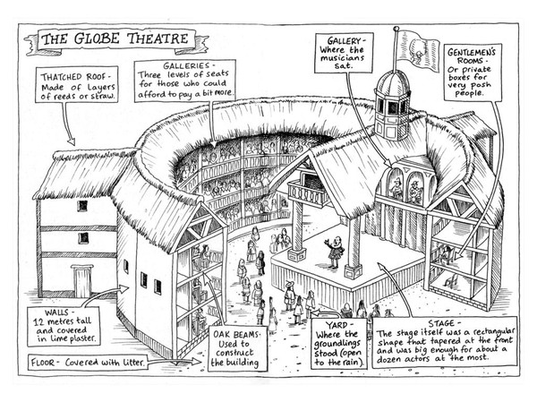
Source C: Like the Pilgrims, the Puritans were English Protestants who believed that the reforms of the Church of England did not go far enough. [They left England] and [a]rriving in New England, the Puritans established the Massachusetts Bay Colony in a town they named Boston. Life was hard, but in this stern and unforgiving place they were free to worship as they chose. The Bible was central to their worship. Human beings were depraved sinners. God had chosen a few people, "the elect," for salvation. The rest of humanity was condemned to eternal damnation. But no one really knew if he or she was saved or damned; Puritans lived in a constant state of spiritual anxiety, searching for signs of God's favor or anger. The experience of conversion was considered an important sign that an individual had been saved. Faith, not works, was the key to salvation. The experience of conversion did not happen suddenly; it proceeded in fits and starts punctuated by doubt, as divine power worked its way on fragile human material. But it was not only individual salvation that mattered; the spiritual health and welfare of the community as a whole was paramount as well, for it was the community that honored and kept the covenant. The integrity of the community demanded religious conformity. Dissent was tolerated, but only within strict limits. The colony survived, but over time its religious fervor diminished. Scholars disagree about when and why this happened. The Puritans themselves found it difficult to maintain a society in a state of creative uncertainty. http://www.pbs.org

Source B: Drama at Shakespeare’s time – and at Shakespeare’s Globe Theatre – was characterised by a tug of war between a disapproving puritanical attitude to theatre by the city councillors on the one hand, and royal approval on the other. The city fathers resented royal patronage and regarded it as interference in their affairs. This battle went on until finally, in 1642 and 1644, all the theatres were destroyed under order of Parliament. We have therefore had great difficulty in gaining a good picture of what Elizabeathan theatres were really like. We don’t even know exactly where the Shakespeare’s Globe Theatre stood, although we can get quite close, and indeed, there is a splendid reconstruction of it, which is now one of London’s most popular theatres and biggest tourist attractions.
The groundlings paid a penny to stand in the pit of the Globe Theatre. The others sat in the galleries. The very grand could watch the play from a chair set on the side of the stage itself. Theatre performances were held in the afternoon, because they needed the daylight. The turnover of plays was unimaginable to the modern mind. The theatres could often present eleven performances of ten different plays in two weeks. The actors generally got their lines only as the play was in progress – very different from the well-rehearsed performances that we expect these days. There would be someone backstage whispering the lines and the actors would then repeat them. Women were not allowed to appear on the stage so the female roles were played by men and boys.
http://www.nosweatshakespeare.com/resources/globe-theatre/

OUTLINE:
Possible Topics: *Please circle or highlight the two that you are going to address.
- Beginnings of the theatre
- Layout of the theatre
- The theatre’s audience
- The closing of the theatre
Body Paragraph 1:
TS: State the main idea of your paragraph (When did the theatre/How did theatre begin? OR What is the layout like? OR What is the audience like? OR When and why did it close??)
EV: Introduce and use one quote from the sources to prove your topic sentence.
CM: Explain what your quote teaches us about your topic.
CM: Explain more about what your quote teaches us about your topic.
EV: Introduce and use one quote from the sources to prove your topic sentence.
CM: Explain what your quote teaches us about your topic.
CM: Explain more about what your quote teaches us about your topic.
CS: Sum it up.
Body Paragraph 2:
TS: State the main idea of your paragraph (When did the theatre/How did theatre begin? OR What is the layout like? OR What is the audience like? OR When and why did it close??)
EV: Introduce and use one quote from the sources to prove your topic sentence.
CM: Explain what your quote teaches us about your topic.
CM: Explain more about what your quote teaches us about your topic.
EV: Introduce and use one quote from the sources to prove your topic sentence.
CM: Explain what your quote teaches us about your topic.
CM: Explain more about what your quote teaches us about your topic.
CS: Sum it up.

