In ‘Lord of the Flies’ Remake, Girls Survive Instead

By DANIEL VICTOR
AUG. 31, 2017
Photo
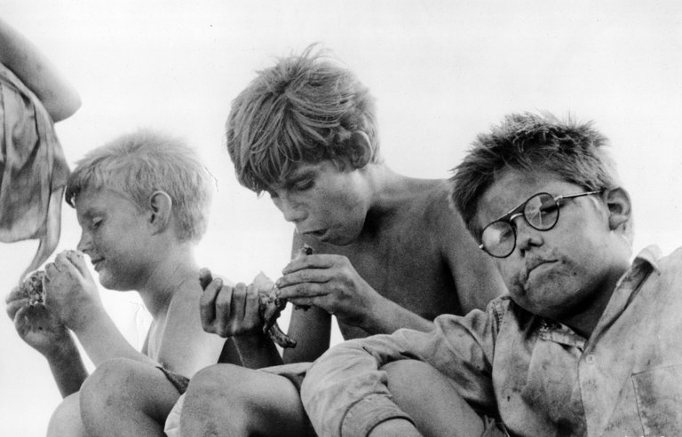
A scene from the 1963 film “Lord of the Flies.” CreditPhotofest

A planned film adaptation of “Lord of the Flies,” the 1954 novel that examined the inherent evil of humanity through an island of boys without adult supervision, will have a provocative twist: This time, the island will be full of girls.
The concept alone invited immediate scrutiny on social media. But skepticism was inflamed by a fairly common Hollywood story: The film about girls will be written and directed by two men, Scott McGehee and David Siegel.
The two men have reportedly made a deal with Warner Bros. to create the movie. Mr. Siegel told Deadline, which reported the news, that they intended to do “a very faithful but contemporized adaptation of the book.”
Scott McGehee, left, and David Siegel plan an all-girls “Lord of the Flies.” CreditAmanda Edwards/Getty Images

Using girls “might help people see the story anew,” Mr. McGehee said.
“It breaks away from some of the conventions, the ways we think of boys and aggression,” he said. “People still talk about the movie and the book from the standpoint of pure storytelling. It is a great adventure story, real entertainment, but it has a lot of meaning embedded in it as well.”
Together, the two directed the films “The Deep End” in 2001 and “What Maisie Knew” in 2013. Theirs would be at least the third adaptation of “Lord of the Flies,” after a 1963 version and another one in 1990. Warner Bros. did not immediately respond to a request for comment on Thursday.
In the book — spoiler alert — things go badly for the preteen boys, classmates from an English boarding school who become stranded on an island without adults. They first try to work together to survive, but their new society quickly unravels as distrust and violence set in. A favorite of high school English classes, the story has for decades been seen as a cautionary look at how members of mankind can treat one another poorly.
But is it about mankind or about men? Flipping the gender dynamics would lead to an entirely different story, several people argued.
An all women remake of Lord of the Flies makes no sense because... the plot of that book wouldn't happen with all women.
— roxane gay (@rgay) Aug. 31, 2017
I mean, "Lord of the Flies" is about toxic masculinity. Hollywood should just have two women write a major film ABOUT TOXIC MASCULINITY.
— Charles Clymer️‍ (@cmclymer) Aug. 31, 2017
the thing about lord of the flies is that it's about systemic male violence + how it replicates
— #rachelsyme (@rachsyme) Aug. 30, 2017
In an undated interview, the author of the book, William Golding, who died in 1993, said he was often asked why he wrote about boys instead of girls. He said that it was partly because he grew up as one, but that gender was also crucial to the larger point of the novel.
“If you land with a group of little boys, they are more like scaled-down society than a group of little girls would be. Don’t ask me why, and this is a terrible thing to say, because I’m going to be chased from hell to breakfast by all the women who talk about equality. This has nothing to do with equality at all. I mean, I think women are foolish to pretend they’re equal to men — they’re far superior and always have been. But one thing you cannot do with them is take a bunch of them and boil them down, so to speak, into a set of little girls who would then become a kind of image of civilization, of society.”
Gender reversals in reboots are not new for Hollywood: A “Ghostbusters” with a cast of women was a critical and box office success last year, and women will be the outlaws in the upcoming “Ocean’s 8.” And teenage girls have long been awful to one another on screen, as seen in “Mean Girls” and “Heathers.”
What remains to be seen is whether the new “Lord of the Flies” will offer largely a mirror image of the novel, subbing in girls without changing the central plot points and behavior of the characters, or if it will wrestle with how girls would approach their fate differently.
“It could be problematic if all they’re doing is switching out girls for boys and saying, ‘Well, girls would do this too,’” said Pamela Davis-Kean, a professor of psychology at the University of Michigan who studies children and families.
Though many differences between boys and girls tend to be overstated, boys do tend to be more physically aggressive, she said. Some of the novel’s scenes of physical violence probably wouldn’t align with how girls would settle their issues, especially in the era of the book, she said.
The depth of collaboration could be another departure, she said. While the boys in the book did try to set up effective communication methods, like only speaking when holding a conch shell, they largely ended up deferring to leaders. Girls would be more likely to hear more ideas and deliberate, Ms. Davis-Kean said.
“My guess would be a lot more time in the shell circle trying to figure out what to do,” she said.
https://www.nytimes.com/2017/08/31/arts/lord-of-the-flies-girls.html

