Introduction to Greek Mythology Name: __________________________
PowerPoint Presentation
The Olympians: _______________ is the home of the Gods.
Aphrodite:
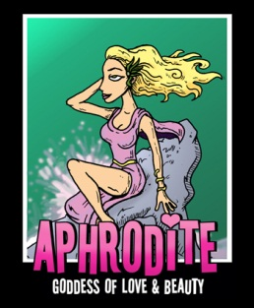
Aphrodite sprang up from _______________. She is the most _______________ Goddess and is married to _______________.
Apollo:
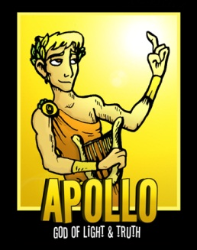
He has a twin sister named ________________. His instrument is the _______________.
Ares:
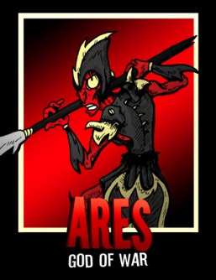
Ares is the _______________ Olympian, and even his mother_______________ him.
Artemis:
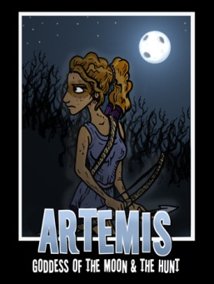
Her twin brother is_______________. Artemis never wed, nor had any _______________.

Athena:
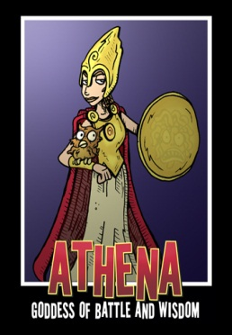
Athena is said to have _______________ from Zeus’ head full grown. Poseidon and Athena battle over the city of _______________. Being a virgin goddess, Athena, refuses to _______________.
Demeter:
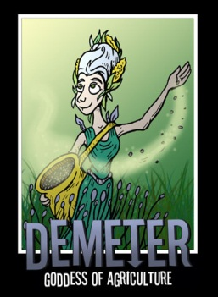
She has a deep connection with _______________. Demeter lives on _______________, not on Mount Olympus, unlike most gods. Her daughter is _______________.
Dionysus:
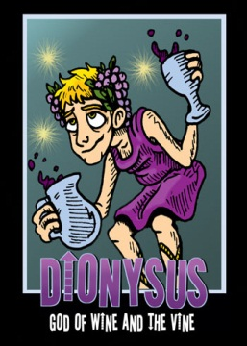
Dionysus is the god of the vine, _______________ and theater. He is the only god with one ________________ parent.
Hades:
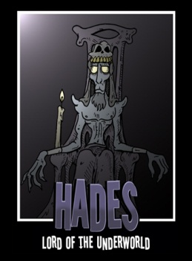
Hades does not _______________ when a mortal ________________; he just guides their souls to the _______________.

Hephaestus:
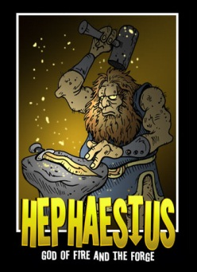
Hephaestus is the god of _______________. He is said to the only ugly god, and is ironically the husband of ______________, the most stunning goddess. He uses his ______________ to make armor and weaponry for the other gods.
Hera:
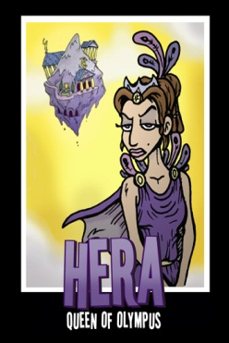
Hera is the goddess of ______________. She is the very jealous wife of _________________, and the mother of ______________ and ________________.
Hermes:
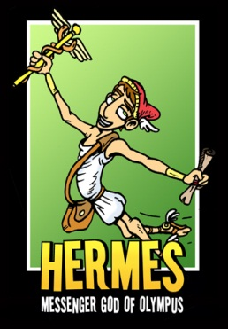
Hermes is the popular ______________ god. He also helps escort the dead to the ______________.
Hestia:
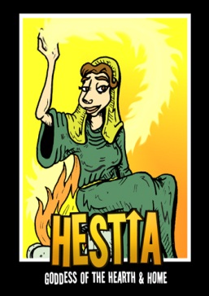
Hestia is known as the goddess of the ______________ and hearth. When sitting down to eat, Greeks and Romans ______________ to her and ask her to bless their meals.

Persephone:
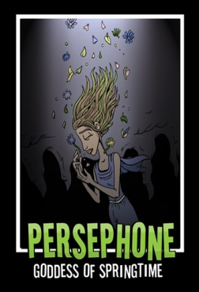
She is the goddess of ______________. Persephone was spotted by Hades and forced to become his ______________. She is also the daughter of ______________, goddess of harvest.
Poseidon:
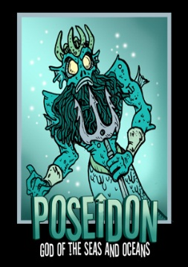
Poseidon is the god of the ______________ and ______________. He is the brother of the almighty ______________. He is known to have powerful ______________ swings, and that is said to cause the ocean to create waves.
Zeus:
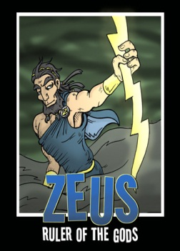
Zeus is said to be the most powerful god and that he carries a ______________ bolt with him at all times. Zeus is unfaithful to his wife, ______________, and has many children with mortals, ______________, and other goddesses.

Myths Explain and Teach:
- About the natural word and _______________.
- About answers to _______________ questions.
- About the origin of man/creation.
- How to _______________.
- The importance of decisions and _______________.
- About good and ______________.
Reasons to Study Greek Mythology:
- Learn about _______________ culture.
- Makes the reader think about ______________.
- Provides us with a different outlook on how the _______________ was created.
- References to mythology in: ________________________________________.

